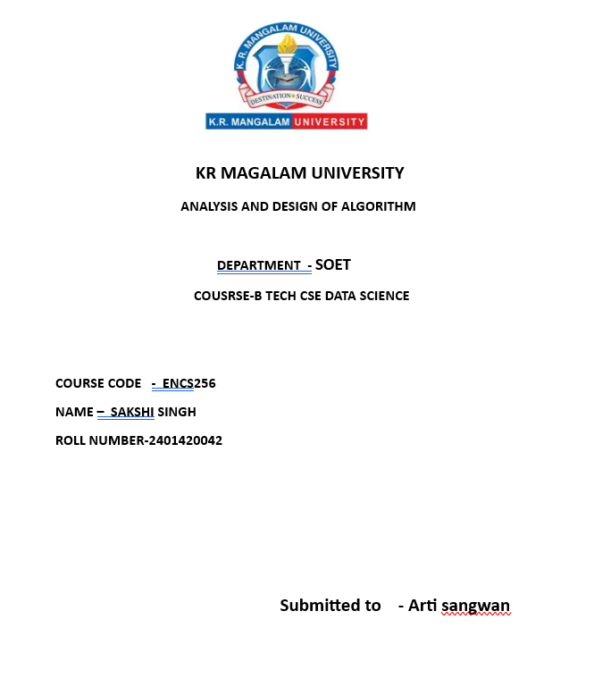

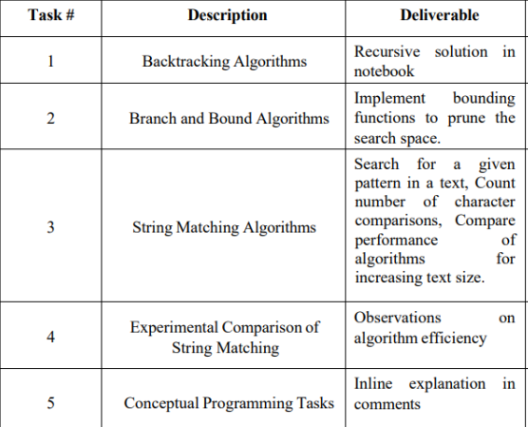

Backtracking is a problem-solving technique used to find all possible solutions by exploring every potential option and abandoning (backtracking) those that do not satisfy the problem constraints.
In this task, the N-Queens problem is implemented using backtracking. The goal is to place N queens on an N×N chessboard such that no two queens attack each other. A queen can attack horizontally, vertically, and diagonally.
For each column, it tries placing a queen in every row.
- Before placing, it checks whether the position is safe using the is_safe() function.
- If the position is safe, the queen is placed and the algorithm moves to the next column.
- If no valid position is found, it backtracks by removing the previously placed queen and tries another position.
This approach ensures all possible configurations are explored but avoids invalid ones early, making it efficient compared to brute force.
Code and output:
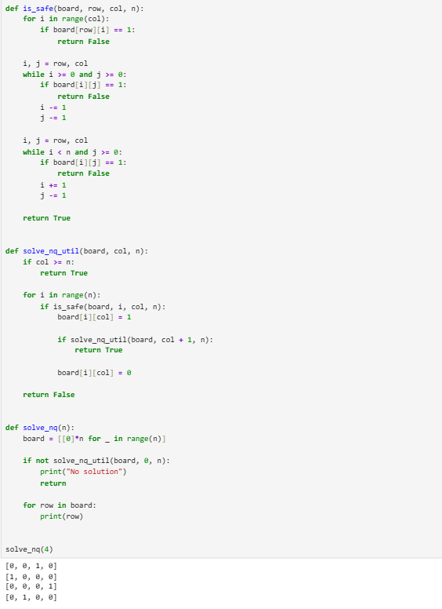
Branch & Bound avoids exploring unnecessary nodes using bounding function.
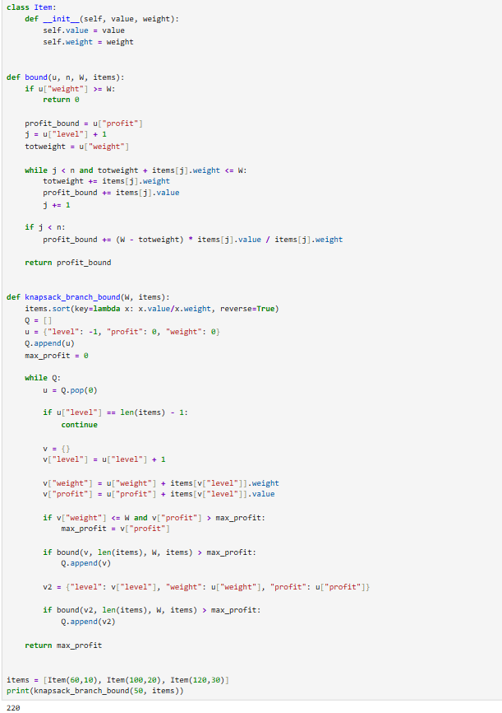
String matching is the process of finding occurrences of a pattern within a given text.
In this task, the Naive String Matching Algorithm is implemented. It works by:
- Sliding the pattern over the text one position at a time.
- At each position, characters of the pattern are compared with the text.
- If all characters match, the pattern is found.
- If a mismatch occurs, the algorithm shifts the pattern by one position and continues.
Additionally, the algorithm counts the number of character comparisons, which helps in analyzing performance.
Although simple, this approach is inefficient for large inputs because it performs redundant comparisons.

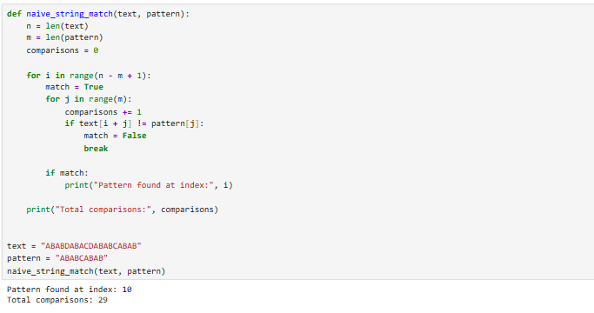

This task focuses on analyzing the efficiency of the string matching algorithm by testing it on different input sizes.
Steps performed:
- Text strings of increasing sizes are generated.
- The same pattern is searched in each text.
- The time taken for execution is recorded using time functions.
- Results are plotted on a graph with:
  - X-axis → Input size
  - Y-axis → Execution time
The graph shows how the algorithm's performance changes as input size increases.
For the naive algorithm, the time complexity is O(n × m), so the graph typically shows a linear or slightly increasing trend.
This experiment helps in understanding algorithm scalability and efficiency.

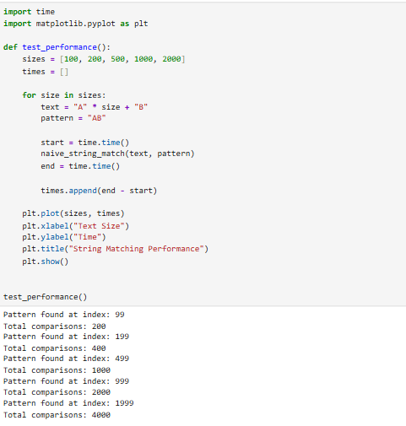

Output graph :

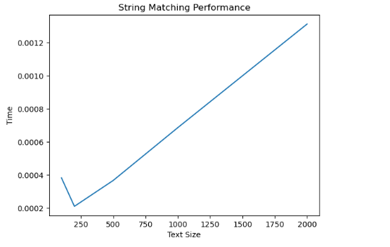

This task focuses on writing clean and understandable code using inline comments.
A recursive factorial program is used as an example:
- The function calls itself until a base condition is reached.
- Comments explain:
  - Base case (termination condition)
  - Recursive step (function calling itself)
Inline comments improve readability and help others understand:
- Logic of the program
- Flow of execution
- Purpose of each step
This is an important programming practice, especially in collaborative and academic environments.
